3.2.4 Листинги

Отправка электронных писем
Создать новый почтовый ящик на яндекс. Перейти по ссылке и создать пароль приложения https://id.yandex.ru/security/app-passwords

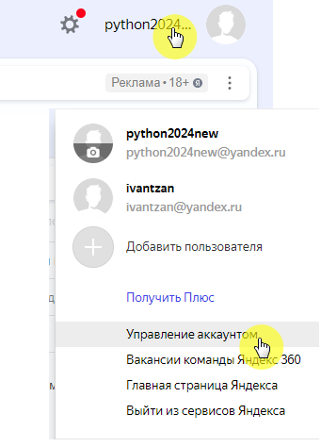
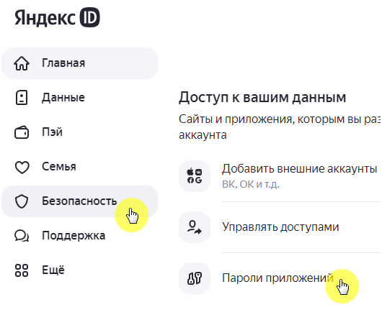
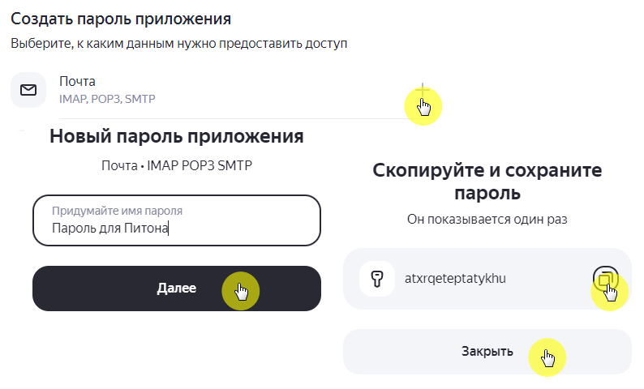
Разрешить доступ к ящику почтовым программам
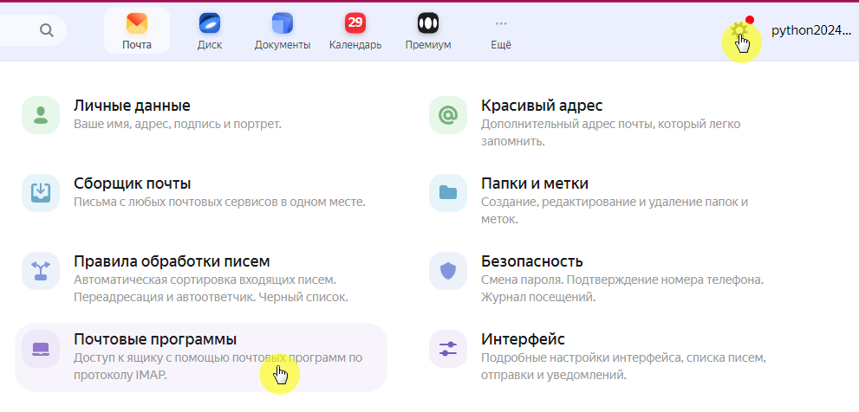
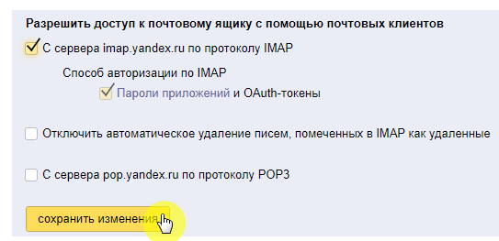

import smtplib
from email.message import EmailMessage

sender_email = 'python2024new@ya.ru'
recipient_email = 'ivantzan@ya.ru'
password = 'atxrqeteptatykhu' #Это пароль приложения! Не ящика!
subject = 'Проверка связи №1'
body = 'Привет №1 из Питона!'

msg = EmailMessage()
msg.set_content(body)
msg['Subject'] = subject
msg['From'] = sender_email
msg['To'] = recipient_email

server = None

try:
# Использование порта 465 для SSL
server = smtplib.SMTP_SSL('smtp.yandex.ru', 465)
server.login(sender_email, password)
server.send_message(msg)
print('Письмо отправлено!')
except Exception as e:
print(f'Ошибка: {e}')
finally:
if server:
server.quit()

Добавляем интерфейс

from tkinter import *
import smtplib
from email.message import EmailMessage

def send_email():
sender_email = sender_email_entry.get()
recipient_email = recipient_email_entry.get()
password = password_entry.get()
subject = subject_entry.get()
body = body_text.get("1.0", END)

msg = EmailMessage()
msg.set_content(body)
msg['Subject'] = subject
msg['From'] = sender_email
msg['To'] = recipient_email

server = None

try:
server = smtplib.SMTP_SSL('smtp.yandex.ru', 465)
server.login(sender_email, password)
server.send_message(msg)
result_label.config(text='Письмо отправлено!')
except Exception as e:
result_label.config(text=f'Ошибка: {e}')
finally:
if server:
server.quit()

# Создание главного окна
window = Tk()
window.title("Отправка Email")
window.geometry("500x300")
# Создание и размещение виджетов
Label(text="Отправитель (Email):").grid(row=0, column=0, sticky=W)
sender_email_entry = Entry(window)
sender_email_entry.grid(row=0, column=1)

Label(text="Получатель (Email):").grid(row=1, column=0, sticky=W)
recipient_email_entry = Entry(window)
recipient_email_entry.grid(row=1, column=1)

Label(text="Пароль приложения:").grid(row=2, column=0, sticky=W)
password_entry = Entry(show="*")
password_entry.grid(row=2, column=1)

Label(text="Тема:").grid(row=3, column=0, sticky=W)
subject_entry = Entry(window)
subject_entry.grid(row=3, column=1)

Label(text="Сообщение:").grid(row=4, column=0, sticky=N)
body_text = Text(height=10, width=45)
body_text.grid(row=4, column=1)

Button(text="Отправить", command=send_email).grid(row=5, column=1, sticky=E)

result_label = Label(text="")
result_label.grid(row=6, column=1, sticky=W)

# Запуск главного цикла окна
window.mainloop()

Сохраняем емейлы и пароль в текстовом файле

from tkinter import *
import smtplib
from email.message import EmailMessage

def save():
with open("save.txt", "w") as file:
file.write(sender_email_entry.get() + '\n')
file.write(recipient_email_entry.get() + '\n')
file.write(password_entry.get() + '\n')

def load():
try:
with open("save.txt", "r") as file:
credentials = file.readlines()
sender_email_entry.insert(0, credentials[0].strip())
recipient_email_entry.insert(0, credentials[1].strip())
password_entry.insert(0, credentials[2].strip())
except FileNotFoundError:
# Файл не найден, игнорируем ошибку
pass

def send_email():
save()
sender_email = sender_email_entry.get()
recipient_email = recipient_email_entry.get()
password = password_entry.get()
subject = subject_entry.get()
body = body_text.get("1.0", END)

msg = EmailMessage()
msg.set_content(body)
msg['Subject'] = subject
msg['From'] = sender_email
msg['To'] = recipient_email

server = None
try:
server = smtplib.SMTP_SSL('smtp.yandex.ru', 465)
server.login(sender_email, password)
server.send_message(msg)
result_label.config(text='Письмо отправлено!')
except Exception as e:
result_label.config(text=f'Ошибка: {e}')
finally:
if server:
server.quit()

window = Tk()
window.title("Отправка Email")
window.geometry("500x300")
Label(text="Отправитель (Email):").grid(row=0, column=0, sticky=W)
sender_email_entry = Entry(window)
sender_email_entry.grid(row=0, column=1)

Label(text="Получатель (Email):").grid(row=1, column=0, sticky=W)
recipient_email_entry = Entry(window)
recipient_email_entry.grid(row=1, column=1)

Label(text="Пароль приложения:").grid(row=2, column=0, sticky=W)
password_entry = Entry(show="*")
password_entry.grid(row=2, column=1)

Label(text="Тема:").grid(row=3, column=0, sticky=W)
subject_entry = Entry(window)
subject_entry.grid(row=3, column=1)

Label(text="Сообщение:").grid(row=4, column=0, sticky=N)
body_text = Text(height=10, width=40)
body_text.grid(row=4, column=1)

Button(text="Отправить", command=send_email).grid(row=5, column=1, sticky=E)

result_label = Label(text="")
result_label.grid(row=6, column=1, sticky=W)

# Загрузка сохраненных данных
load()

window.mainloop()
Проверка корректности введенного емейл

from tkinter import *
import smtplib
from email.message import EmailMessage
from email.utils import parseaddr

def validate_email(email):
""" Проверка email на соответствие стандартному формату. """
name, addr = parseaddr(email)
return '@' in addr and '.' in addr.split('@')[-1]

def send_email():
sender_email = sender_email_entry.get()
recipient_email = recipient_email_entry.get()

# Проверяем оба email-адреса
if not validate_email(sender_email) or not validate_email(recipient_email):
result_label.config(text='Ошибка: Неверный формат email')
return

password = password_entry.get()
subject = subject_entry.get()
body = body_text.get("1.0", END)
save()
password = password_entry.get()
subject = subject_entry.get()
body = body_text.get("1.0", END)

